**Minecraft Drawing Program**

**100 Points   Please submit the py file.**

**Introduction**

In this assignment, you will continue your foray into the world of Python Turtle Graphics. Instead of creating a single Minecraft tile as in Assignment 3, you will use Python **functions** to create two or more types of Minecraft tiles. Once the tile functions are created, you should use them to create an elaborate Minecraft drawing.

**Assignment**

Use Python Turtle Graphics to design and draw a complex object that might appear in Minecraft. **DO NOT DO A CASTLE!!!!!** Here is a drawing of a castle that could potentially earn all 100 points.

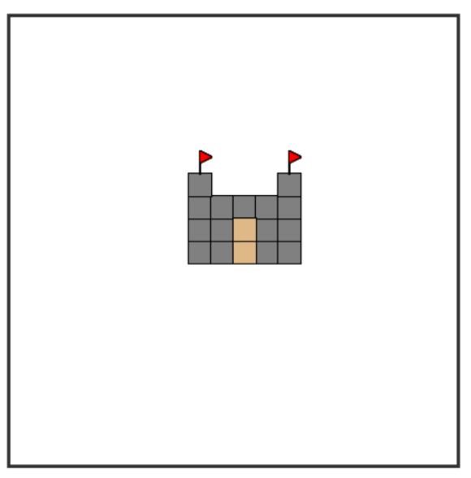

**Requirements and Grading**

* 20 points - There are at least two types of tiles in the drawing. In the sample castle drawing, one type of tile is a square and the other is a flag.
* 20 points - Each tile is defined in a function. The function should draw the tile in a square that is 20 pixels wide and 20 pixels tall.
* 20 points - Each function should be general. For example, the square tiles in the castle drawing are produced by calling a function with this information: the turtle that should be used to draw the tile, the x coordinate of the tile, the y coordinate of the tile and the color to use.
* 20 points - The Python solution is easy to understand and does not contain unnecessary code. (Remember to put an appropriate comment at the top of the Python solution.)
* 20 points - The drawing looks good and would impress your friends.

**Helpful Hint**

* Take a look at the turtle method [summary](http://interactivepython.org/runestone/static/thinkcspy/PythonTurtle/SummaryofTurtleMethods.html) to remind yourself what is possible.